Voice Coach — Análisis de voz
Idioma: English · Duración: 27s · Palabras: 56 · Ritmo: 123 ppm · Positividad: 67% · Muletillas: 0 · Generado: 7/11/2026, 1:25:01 PM

Métricas


Arco de sentimiento
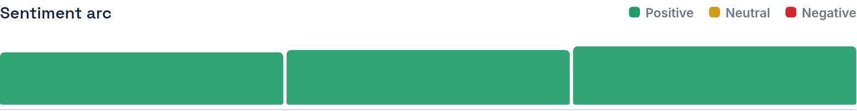

Transcripción
When the executive from the USA called to Latin America, they are looking for competitive salaries and others who can speak Portuguese. Last year, I decided to pursue a career in a corporate business negotiation team and currently I'm studying chemistry and English. These are true for but through hard work, you can achieve your goals.
Color del texto — Verde: positivo · Amarillo: neutral · Rojo: negativo

